62.03.27
To Clement Hodgkinson
E62/2398, unit 38, VPRS 44/P inward registered and unregistered correspondence, VA 538 Department of Crown Lands and Survey, Public Record Office, Victoria.

Melbourne botanic Garden
27 March 1862.
Sir
I have the honor to report to you, that about one fourth of the lines of trenching is completed between the city bridge and the botanic Garden and that for the purpose of planting the elm avenue the ground of the lines, as far as completed, is prepared. The wages paid to the labourers from the Immigration Depot being only 2/ per diem I have been able to carry out this portion of the work for the £10. -. - granted by the Board of Land and Works for the purpose. I beg now to solicit, that the board will be pleased to grant an additional sum of £30. -. - (thirty pounds Sterling) for the completion of the lines as marked on the plan of the accompanying sketch. You will thereby also perceive, that I propose to plant three elms between each two Gumtrees, so that if after a series of years it should be desired, the Eucalypti may be obliterated and still by removal of each third elm the symmetry of the plantation be retained.
It will be unnecessary to say, that the elms are to be supplied from the botanic Garden and I hope that the necessary stakes will be supplied by the office of public works, a requisition being submitted for the purpose. The Board will thus also be aware, that beyond the continued employment of the Gardener (engaged for many months past) no additional expense will be involved by the completion of this avenue. The Gardener will plant, if it meets with the approval of the board, several hundred pines on the declivities of the Yarra ridges, the pines to be supplied from the botanic Garden.
I have the honor to be,
Sir,
your most obedient servant
Ferd. Mueller.

Clem. Hodgkinson Esq.
&c &c &c

P.S.
I beg to mention, that it would be desirable to complete the trenching during April, so that the trees may be planted early in May, the locality being barren and exposed
F.M.

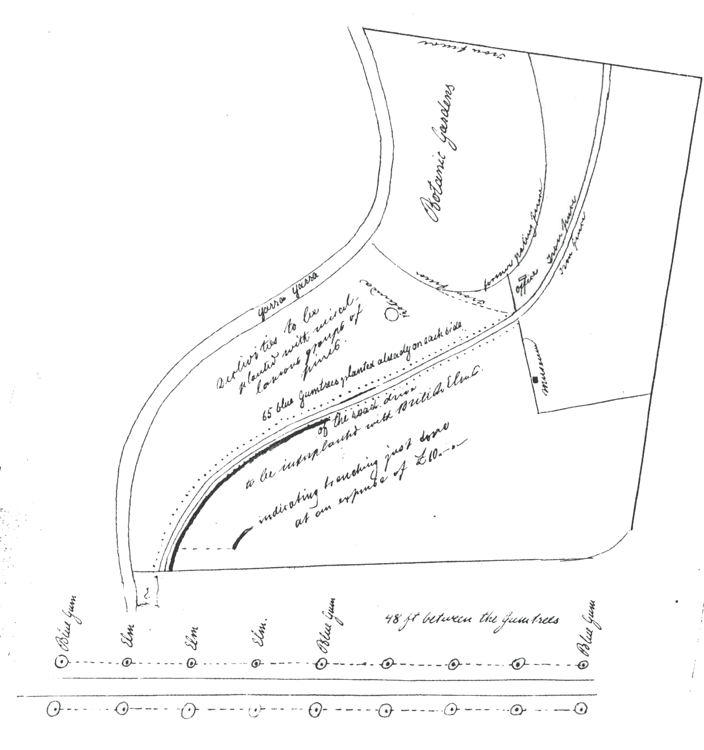

For reply see C. Hodkinson to M, 13 May 1862.
62-03-27_image01.jpg.
Hodgkinson minuted on 8 May 1862: 'Owing to the many drains on the vote for fencing and improving Public Parks & Gardens I cannot now recommend the appropriation of a larger sum than £10 in addition to that already granted for the purpose of trenching the ground in question. I beg to recommend for the approval of the Board Dr Muellers proposal to plant pines on the slopes of this Reserve.' The Board of Land and Works informed Hodgkinson that they approved his recommendations on 9 May, and M was informed on 13 May. See also M to C. Duffy, 12 April 1862.

